

**Prepared for:**

Dr. Aref Mahdavi Ardekani

**Course:MScFinance**

**Institution:DublinCityUniversity(DCUBusinessSchool)**

**Module:**

**FBA1026 - Financial Innovation and Technology**

**Title:**

**The FinTech Revolution – Analyzing Innovation and Impact**

**(FinTech Banks & Neobanks - REVOLUT)**

**Prepared by:**

Cliffton John Rodrigues: A00046343

Swetha Shankar Ganesh Moorthi: A00047808

Mankaa Jain: A00045771

Vikas Gupta: A00047802

Udit Ganglani: A00045535

## **Executive Summary**

The economic modern technology (FinTech) market has actually experienced transformative development, driven by advancements that mix innovation with economic solutions to boost availability, effectiveness, as well as client experience. Among the leading gamers in this electronic change is Revolut, a London-based FinTech firm established in 2015 by Nik Storonsky as well as Vlad Yatsenko. At first released as a multi-currency card company, Revolut has actually advanced right into a thorough monetary incredibly application, using solutions such as worldwide compensations, cryptocurrency trading supply trading budgeting devices as well as company financial remedies.

Revolut's disturbance of standard financial comes from its capacity to remove ineffectiveness, deal clear prices as well as make it possible for borderless economic services-- all powered by innovative modern technologies like AI installed financing, and also cloud computer. By 2025, Revolut flaunts over 50 million clients worldwide plus an assessment surpassing $25 billion placing itself as a worldwide FinTech leader. This record discovers Revolut' s organization version affordable landscape, earnings streams and also connected dangers.

The data-driven evaluation exposed that while Revolut leads in item technology, it deals with substantial obstacles such as regulative obstacles functional threats, together with enhancing competitors. Secret referrals consist of calculated diversity market development, improved regulative conformity, as well as proceeded AI combination to maintain affordable benefit as well as lasting development.

## **Introduction**

Dynamic and energetic, the industry of financial technology or FinTech is that branch of the economy that merges technology with financial services to enhance efficiency, accessibility, and user experience. FinTech innovations range from digitalized payments through new delivery methods like blockchain and AI to embedded finance services. It enhances financial accessibility, reduces operational cost, and brings about inclusion in finance among the underbanked masses all over the world (Speednet Software, 2025). Growth in the FinTech sector has been overwhelming for over ten years, with revenues reported to rise at an impressive 14% compounded annually in 2024, all credit going to the evolution of mainstream AI and embedded finance (Lloyds Banking Group, 2025).

In 2015, Nik Storonsky and Vlad Yatsenko launched Revolut, a strong FinTech. Starting as a multi-currency card provider, it has blossomed into a financial super app for international remittances, cryptocurrency trading, stock trading, and budgeting tools. With the support of state-of-the-art technologies like AI-powered assistants and embedded finance solutions, Revolut disrupted old-fashioned banking models and garnered more than 50 million customers worldwide by 2025 (Revolut, 2024).

Revolut is significant because it bridges the gap in the financial sector by fixing inefficiencies in traditional banking systems. With simple and costless settlement of cross-border transactions, traditional banks are notorious for levying exorbitant fees on them in the absence of real-time management tools for the client cash flow. Instead, Revolut provides a suite of services that are cost-competitive with transparent pricing and with customer-oriented user experiences (Fintech Magazine, 2025). As more activities grow in the direction of AI surfaces and digital mortgages, full steam ahead towards innovation and adaptability to changing client needs underline these developments. With an increased demand for hyper-personalized financial services, the relevance of Revolut in the future growth of global banking is growing stronger.

## **Business Model & Competitive Analysis**

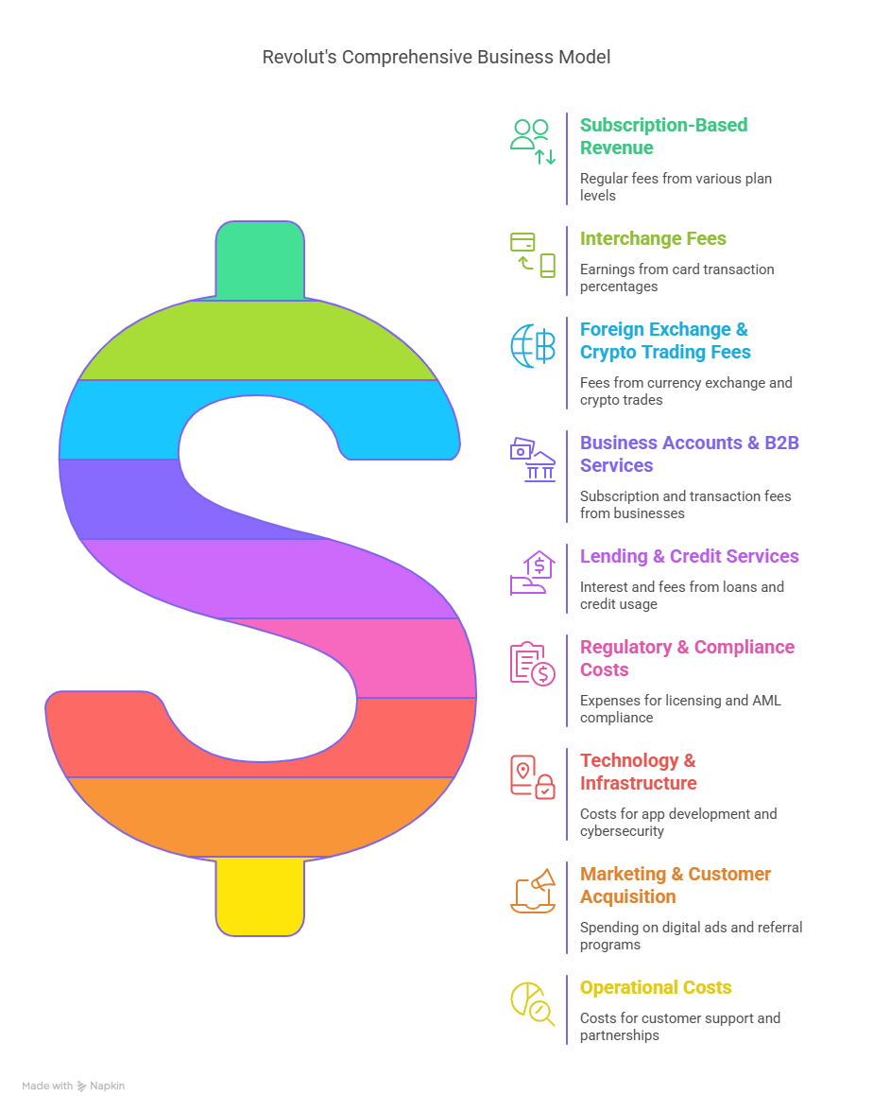

**How Revolut Works**

Revolut is a digital banking application offering a wide range of financial services to individuals and businesses through its mobile app. Its major features include the following:

• Users can keep, convert and transfer money more than 30 currencies at their interbank rates.

• AI-Powered Assistant: It uses your behaviour in the app to provide personalized financial coaching.

• Subscription Tiers: Free access along with premium plans adding perks such as travel insurance. Priority customer service is also part of the subscription.

• Integrated Finance: The incorporation of services that are not classified under finance, such as e-commerce payments services, within the app (LinkedIn, 2025).

Revolut’s infrastructure leverages cloud computing for scalability and advanced security measures like biometric authentication to ensure data protection (Lloyds Banking Group, 2025). Its focus on user-centric innovation positions it as a leader in the FinTech sector.

**Revenue Model**

Revolut generates income through several streams:

1. **Subscription Fees**: Premium plans such as “Ultra” contribute approximately 14% of total revenue.
2. **Transaction Fees**: Charges for ATM withdrawals exceeding limits or international transfers account for ~27%.
3. **Foreign Exchange Margins**: Profits from currency conversions beyond interbank rates (~17%).
4. **Interest Income**: Revenue from lending products like overdrafts (~28%).
5. **Other Income Sources**: Includes cryptocurrency trading fees (~10%) and stock trading commissions (~5%) (Johnson, 2025).

Revolut’s diversified revenue model ensures resilience against market fluctuations while enabling continuous investment in product development.

**Competitive Landscape**

Revolut faces competition from several FinTech players:

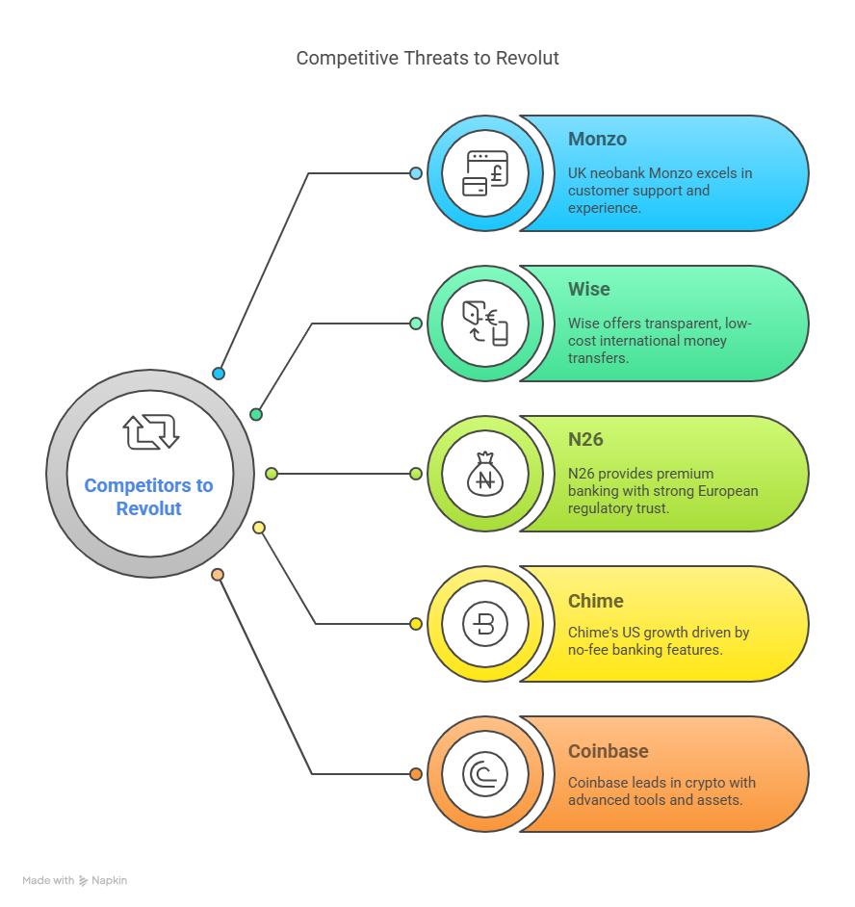

**SWOT Analysis**

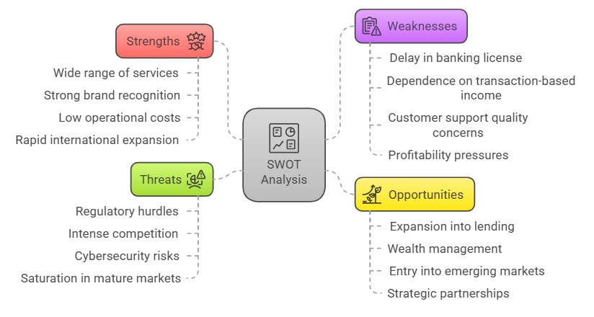

**Financial Performance & Market Impact**

Revolut’s financial performance reflects its aggressive growth strategy:

1. Revenue Growth Revolut's revenue soared from $1.1 billion in 2022 to $2.2 billion in 2023, a 95% increase. Profit before tax was $545 million, and net profit was $428 million—its third consecutive year of profitability (Revolut, 2024).

2. Customer Base Expansion Its customer base grew from 26.2 million in 2022 to 38 million in 2023 (~45% growth). In June 2024, Revolut had 45 million customers (Revolut, 2024).

3. Growth in Customer Deposits & Balances Total customer balances increased from £13.2 billion in 2022 to £18.2 billion in 2023. This reflects higher customer trust and more profound usage of Revolut's financial services (Revolut, 2024).

4. Operational Profitability & Financial Strength Revolut reached profitability with a stupendous turnaround in earnings in the previous three years. Strong growth in operating income and positive EBITDA in 2021 and 2022 further reflects its financial strength (Revolut, 2024).

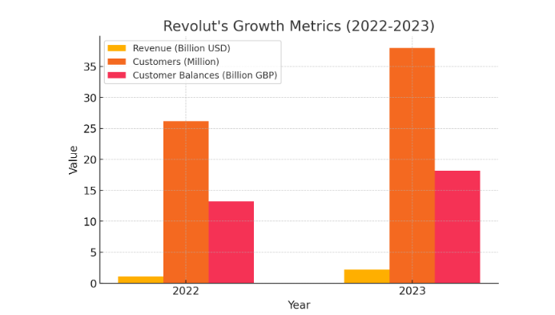

**Market Impact**

Revolut has revolutionized the retail banking landscape in the following ways:

* Providing a borderless financial service: multi-currency bank accounts where customers can send and receive money from banks globally, without requiring physical branches.
* Disrupting the currently monopolistic foreign exchange markets and remittance industry by offering zero or low fees on foreign exchange services.
* Integrated cryptocurrency into mainstream banking on an efficient and widespread basis.
* Forcing traditional banks to adopt a mobile-first strategy.
* Driving a culture of low-cost, digital-only banking.

However, unlike legacy banks, Revolut accesses limited deposit-lending profitability models, due to deposit accessibility and banking license delays in its key markets, such as the UK, inhibiting its long-term scalability compared to legacy banks whose access to low-cost loans is ample with cheap deposits.

## **Data-Driven Analysis (Refer Appendix for the python code)**

## PART-1

## In this part, we have carried out the quantitative risk analysis to examine the key risk factors for neobanks, taking reference of Revolut. The Analysis is done with Python Programming, with pandas, NumPy, Matplotlib and seaborn libraries.

## Dataset Overview

As seen, the dataset was manually constructed to represent different types of risks that typically affect FinTech companies and digital banks. The dataset has two main columns:  
  
•Risk Category: This column consists of six categories of risks pertinent to neobanks operations:  
 1. Regulatory Issues  
 2. Cybersecurity Threats  
 3. Fraud & Financial Crime  
 4. Customer Adoption & Competition  
 5. Reputational Risks  
 6. Operational Risks  
  
• Risk Score: A numerical score indicating the relative weight or severity of each risk category. These scores were pre-assigned based on research and expert judgment to reflect the perceived importance of each risk.

## Risk Score Normalization

To simplify interpretation and comparison across categories of Risk Scores, we scaled and normalized these values onto a Likelihood Scale from 1 to 5 using the following normalization formula:

Likelihood = 1 + 4 × (Risk Score - Minimum Score) ÷ (Maximum Score - Minimum Score)  
  
The normalisation is such that the lowest score for any risk is mapped closer to 1 and the highest score for any risk is mapped to 5. The outputs were rounded to whole numbers for simplicity of interpretation.

## Data Visualization

## After calculating the Likelihood scores, the next step involved visualizing this information through a Bar Plot. In this plot, each bar corresponds to a risk category, with the height representing the Likelihood score on a scale from 1-5. From this visualization, we can observe that Regulatory Issues and Operational Risks have the highest Likelihood Scores, whereas Cybersecurity Threats and Fraud & Financial Crime have a lower score.

## Impact Score & Risk Matrix

To further enrich our analysis, we added a fourth dimension — Impact Score — reflecting the business impact when a corresponding risk is materialized. Impact Score is randomly assigned to each risk bucket, by discretizing into a scale: 1 (low impact) to 5 (high impact).  
  
We then generated a Heatmap in order to have a mapped representation of the Likelihood vs. Impact relationship, each risk category was placed in matrix and based on the high/ low impact/ likelihood they were colored in gradients of intensity.

## Key Findings

From our analysis several insights arise:

1. Regulatory Issues emerged as the most significant risk, scoring high on both Likelihood and Impact.  
2. Operational Risks also showed a high Likelihood score.  
3. Reputational Risks and Customer Adoption & Competition were in the moderate range.  
4. The likelihood of Cybersecurity Threats and Fraud & Financial Crime has scored lower but can have a high impact.

## Conclusion

Through this data exercise, we were able to frame, analyze, and visualize the key risks faced by neobanks. Translating broad risk categories into measurable metrics and visualizations with Python-based data tools enables interested parties (stakeholders, regulators, management teams) to better address risks based on both likelihood and severity of impact on the business.

## Graphical Representation

Risk Category vs. Likelihood Score (Bar Plot)  
The bar plot compares the risk categories to their normalized Likelihood Scores (scaled to 1-5). Regulatory Issues and Operational Risks have the highest perceived likelihood of impacting Neobanks operations. Cybersecurity Threats and Fraud & Financial Crime have relatively less likelihood of impacting the neobank operations.

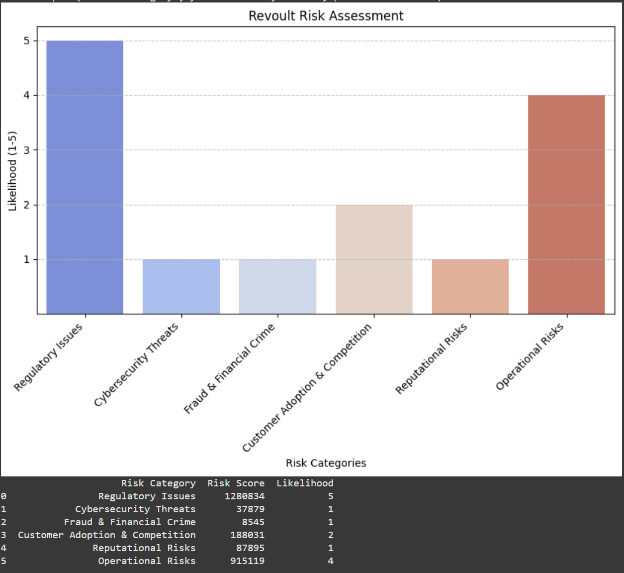

**Limitations**

Since a large part of the exercise was to learn to use Python to perform data analysis in context of risk assessment, we fabricated some "pretend" data to illustrate some various techniques such as normalization, scoring and visualisation. In reality such scores are usually sourced from audit reports, risk assessments or internally generated data which are typically not available to the public.

PART-2

**Stock Market Analysis: FinTech vs Traditional Bank**

**Introduction**

Since Revolut is not publicly listed, we selected PayPal as a representative FinTech stock and AIB as a traditional banking counterpart for comparison. The purpose is to review exactly how a turbulent FinTech gamer varies from a standard financial organization in regards to monetary metrics as well as supply efficiency.

Note: Please refer to Appendix for python codes

**Fundamental Data Comparison**

The basic contrast consists of vital monetary metrics such as Market Capitalization, P/E Ratio, Revenue and also Net Income.  
The data was retrieved using **Yahoo Finance API (yfinance library)**.

| **Metric** | **PayPal (FinTech)** | **AIB Group (Traditional Bank)** |
| --- | --- | --- |
| Market Cap | $664.28 Billion | €14.02 Billion |
| P/E Ratio | 16.83 | 6.56 |
| Revenue | $31.80 Billion | €4.85 Billion |
| Net Income | N/A | N/A |

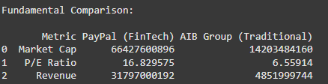

**📈 Observations:**

* PayPal is considerably bigger in market capitalization in contrast to AIB.
* PayPal's P/E Ratio is significantly greater, showing financiers want to pay even more for every system of its revenues-- mirroring greater development assumptions.
* Earnings of PayPal is considerably greater because of its international FinTech service version.

**Stock Price Trend Analysis (AIB Group)**

The stock price of **AIB Group** was analyzed over the period **2020 to 2024**.  
The closing prices were plotted to visualize the trend.

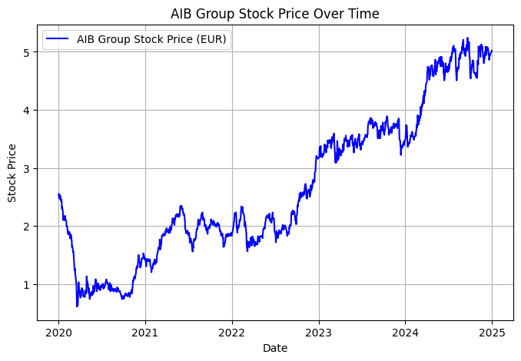

**📈 Observations:**

* The stock price experienced a sharp decrease in early 2020, the stock listed below EUR1 primarily as a result of the COVID-19.
* A **gradual recovery** followed, with the price steadily increasing and crossing the €3 mark by late 2023.
* The stock reached new highs around **€5** in 2024, showing strong recovery and business performance.

**Stock Price Trend Analysis (PayPal)**

The stock price of **PayPal** was analyzed over the period **2020 to 2024**.  
The closing prices were plotted to visualize the trend.

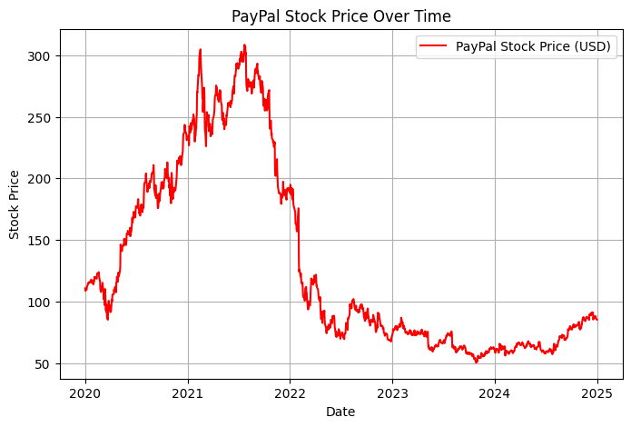

**📈 Observations:**

* Evaluates PayPal’s stock trends, reflecting e-commerce growth, digital payment adoption, and broader FinTech sector impact.
* Examines key fluctuations, analyzing how innovation, regulations, and competition influenced PayPal’s market position.
* Determines investment viability, assessing whether PayPal sustained long-term growth or faced challenges in financial performance.

**Stock Trend Comparison**

The stock price of **AIB Group and PayPal** was analyzed over the period **2020 to 2024**.  
The closing prices were plotted to visualize the trend.

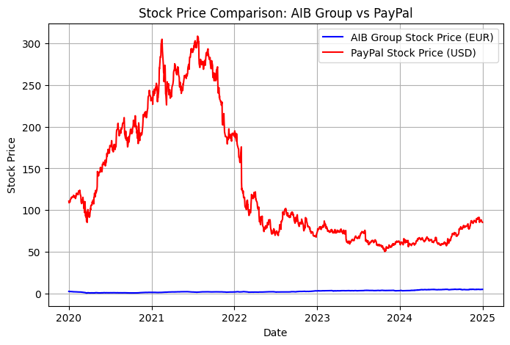

**📈 Observations:**

* PayPal experienced high volatility, rising sharply and then declining, making it a higher-risk investment.
* AIB showed consistent stability, suggesting it is more conservative with steady returns over time.
* Investors seeking growth faced risks with PayPal, whereas AIB offered more predictable returns.

**Stock Volatility Comparison**

A histogram was plotted to compare the **daily returns** of PayPal and AIB Group stocks from **2020 to 2024**.

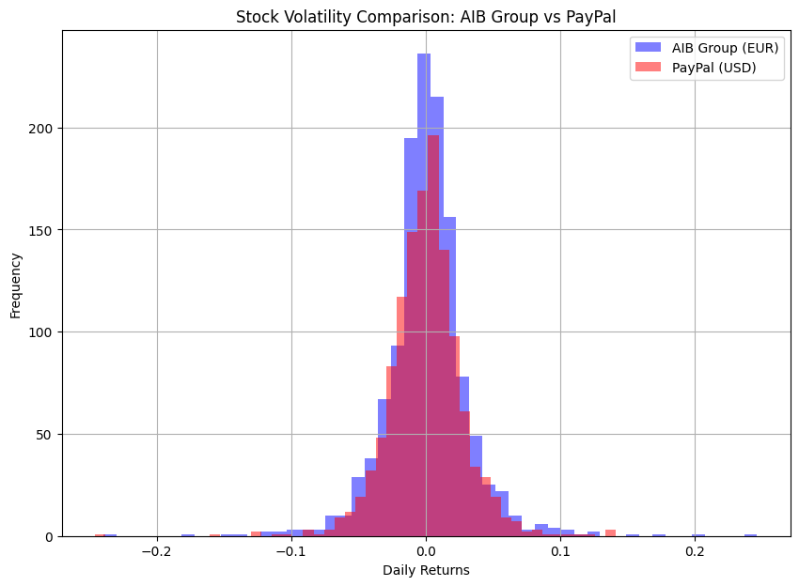

**📈 Observations:**

* Investors seeking stability would favor AIB due to its lower volatility.
* Risk-tolerant investors might see opportunities in PayPal’s price fluctuations for potential high returns.
* Broader market conditions likely played a role in PayPal’s larger return variations.

**5. Conclusion**

The analysis highlights the difference between a FinTech player and traditional bank:

* PayPal is much larger and valued at higher multiples, mirroring market positive outlook around FinTech interruption.
* **Technically,** FinTech stocks like PayPal reveal greater volatility, making them riskier but potentially more rewarding for investors.
* **Traditional bank** like AIB Group offer more stability, with lower valuation metrics and lesser stock price swings.

This comparison reflects how technology-led financial services differ from conventional banking in both market perception and stock performance.

## **Challenges & Risks**

Revolut has been the leader in innovation in the rapidly growing FinTech sector with its innovative digital banking offerings. With its rapid expansion and disruption of the conventional banking sector, however, Revolut is faced by a range of challenges and threats. These include such challenges as regulatory challenges to security threats, frauds, customer take-up, among others, analyzed in this report, and how the company managed to overcome them.  
  
**REGULATORY ISSUES**

One of the greatest risks Revolut has to try to steer clear of is steering clear of the complicated legal environment in most countries(Financial Times, 2023). Revolut works extensively in countries like the EU, the US, and Asia that have different financial regulations. The company has drawn criticism from money regulators, particularly over anti-money laundering (AML) and consumer protection legislation(BBC News, 2023). Obtaining and renewing bank licenses in some places is an annoying thorn in the flesh, too.  
  
**Mitigation Strategies:**Revolut has also tried to fight these regulatory issues by setting up special compliance teams, expanding its panel of regulatory and legal advisors, and acquiring a European bank license in Lithuania that allows it to bank within the EU(Revolut, 2023). The company also actively communicates with regulators to facilitate transparency and compliance with evolving legislation.

**CYBERSECURITY THREATS**  
As a cyber-based banking company, Revolut is likely to be cyber attacked by hacking, data stealing, and ransomware(Forbes, 2022). As a company handling sensitive financial data and crypto transactions, the company is also likely to be cyber attacked by crypto-focused hackers in more intensity.  
  
**Mitigation Measures:**Revolut has mitigated such risks through substantial investment in cybersecurity, including through the use of encryption technologies, multi-factor authentication, and real-time fraud detection controls(Revolut, 2023). The company also keeps customers' accounts under close surveillance for suspicious activity and informs customers at all times on how to secure their accounts.  
  
  
**FRAUD AND FINANCIAL CRIME**

Financial crime, including fraud, identity theft, and money laundering, is a fundamental problem for the financial industry, and Revolut is no different(CNBC, 2023). Financial crime actors have the opportunity to exploit gaps in the company's systems, and this can damage its reputation and users' trust.  
  
**Mitigation Measures:**Revolut has implemented strong Know Your Customer (KYC) and AML controls to counter these risks. It employs artificial intelligence (AI) to track and identify suspicious patterns of behavior, freezes real-time suspicious transactions, and also collaborates with law enforcement agencies to report financial crime.

**CUSTOMER ADOPTION AND MARKET COMPETITION**

Although user acquisition by Revolut has been stellar, this is being hotly challenged by online banks and legacy banks similar to itself such as Monzo and N26(TechCrunch, 2023). Revolut also depends heavily on interchange fees, subscription schemes, and transaction charges, and thus it will have to continue onboarding new customers in order for revenue expansion to take place.  
  
**Mitigation Measures:**Revolut differentiates itself with superior customer experience and ongoing innovation, offering a suite of financial products from cryptocurrency trading to business banking and cross-border consumption(Revolut, 2023). It also invests in retention activities by way of customers' loyalty and collaborations with fashion-forward brands.  
  
  
**REPUTATIONAL RISKS**  
Revolut is already under threat regarding its internal workplace culture and regulatory compliance. One bad word-of-mouth or customer complaint can impact brand reputation and result in customer distrust.  
  
**Mitigation Strategies:**Revolut is open about the issue resolution before occurrence and the emphasis on good business ethics. In a bid not to damage its reputation, Revolut employs artificial intelligence-based sentiment analysis that tracks customer complaints online and resolves issues before they happen(Revolut, 2023). There has also been the addition of another team of customer advocates to handle escalated complains and create customized solutions in an effort to restore trust as well as create stronger brand loyalties.  
  
**COMPETITION BETWEEN TRADITIONAL AND ONLINE BANKS**  
  
Traditional banks fought back by opening up online banking, and fresh FinTech start-ups are continuously emerging(Bloomberg, 2023). Revolut struggles to acquire and retain customers.  
  
**Mitigation Measures:** Product differentiation is where Revolut stands out by adopting disruptive financial products such as blockchain services, cryptocurrency transactions, and artificial intelligence-based financial management solutions(TechCrunch, 2023). Hyper-personalization is leveraged by the company by the use of machine learning in regards to tailored finance information, smart budgeting tips, and savings schemes. In seeking to make a dent in the market, Revolut is moving into underbanked nations and frontier markets where there is vulnerability on the part of the traditional banks, thus driving financial inclusion.

## **REVOLUT'S FUTURE STRATEGIC AND GROWTH CONSEQUENCES**

Revolut has grown giant leaps to become an innovation-thirsty global FinTech giant forged by speedy service innovations. However, since FinTech has also turned very competitive, Revolut must keep innovating and revolutionizing just to be able to maintain the prime spot(Financial Times, 2023).  
  
**FUTURE TRENDS IN REVOLUT'S FINTECH STRATEGY**

Revolut will be at the forefront of much future FinTech innovation, in line with broader wider trends towards artificial intelligence (AI), digital money services, and access to new financial products.  
  
**AI Integration:** Artificial intelligence integration is transforming the provision of financial services, as it can personalize customer experience and operation efficiency. The picture here is Revolut's future AI banking assistant, which, besides responding to customers' questions, will read their minds and offer them personalized advice on their money(Forbes, 2023). As AI is most likely to be the technology of preference in the FinTech sector in the near future, Revolut's first-mover advantage positions it well to lead at personalizing banking services(CNBC, 2023).  
  
**Digital Mortgage Services:** With the demand for instant digital financial services increasing to even niches like mortgages, Revolut's entry into digital mortgages in 2025, beginning with Lithuania, Ireland, and France, is the direction in which the industry is headed. With immediate approval and simple-to-use interfaces, Revolut will revolutionize traditional mortgage services, opening up the new customer base to digital financial services.

**Hybrid Banking Infrastructure:** Online banking gets more mainstream but will always be accompanied by physical touch points the customer will have to walk through in order to trust and use it. Revolut's intelligent ATMs, rolling out in Spain in 2025, is a hybrid model that meets in the middle between the ease of online banking and the security of physical infrastructure. These facial recognition technology ATMs will cater to customers who are not yet ready to be completely digital in their banking by offering a middle ground between physical and digital existence(Revolut, 2023).  
  
**Business Credit Expansion:** Business credit expansion is an extension strategy within the small and medium-sized business (SME) segment. Business credit expansion, as it enters its first European business credit product in 2025, will place Revolut into a high-growth segment while reducing retail consumer reliance and diversifying revenues.

**KEY STRATEGIES TO STAY COMPETITIVE:**

**Diversify and Expand Services Further:**Revolut can diversify and expand its services beyond banking, possibly into newer domains like wealth management, lending, or even new geographies like Asia or Africa(Bloomberg, 2023). Offering more tailored financial products will help them tap untapped customer bases  
  
**Personalization with AI**: As they continue investing in next-advanced AI technology, Revolut can deliver even more personal money tips, automatic savings plans, and investment planning. All these would remind people to think about their service front of mind, leading to user engagement and customer retention.  
 **Enhance Regulatory Compliance:** As the financial services landscape continues evolving, with data privacy regulations and cryptocurrency payments, Revolut has to try its best to stay in regulatory compliance for its markets. Besides, this would not only strengthen evading legal controversy but also trust from regulators and users(BBC News, 2023).  
  
**Focus on Strategic Partnerships and Acquisitions:**Revolut can acquire fintech startups or enter into partnerships with traditional banking institutions to leverage newer technologies or evolving capabilities. For example, a collaboration with traditional banking institutions would allow Revolut to access underpenetrated geographies or markets(Financial Times, 2023).  
  
**Enhance Customer Support and Education:** Offering great customer support and financial education initiatives could retain users. Revolut could provide educational content on investing, budgeting, and cryptocurrency to help users make better decisions when utilizing their platform.  
  
**OPPORTUNITIES FOR EXPANSION AND GROWTH**

**Entering New Markets:**Revolut is already present in new markets globally, with regulated banking licenses in the UK and Mexico(Financial Times, 2023). The company still has room to expand by entering new markets in Europe and tapping into the potential of emerging markets and Asia. Digital mortgages in Lithuania, Ireland, and France are only the beginning, and Revolut can significantly expand its presence in nations where digital financial services are gaining popularity(Bloomberg, 2023).  
  
**Diversification into New Services:**Revolut has already diversified its services from traditional banking to business credit and internet mortgages. It needs to keep diversifying into new services such as investment products, cryptocurrency trading, and insurance. By increasing its product offerings, Revolut can further establish itself as a one-stop-shop for all financial services, attracting more customers(TechCrunch, 2023).

**Strategic Acquisitions and Partnerships:** Revolut can pursue strategic acquisitions of industry participants or acquire smaller ones that are complementary to its service and technology offerings. Acquisitions can help Revolut expand operations and customer base quickly, while partnerships can help facilitate market entry into new geographies and access to newer technologies and customer segments(Forbes, 2023).  
  
**Market Debut and Increased Investor Focus:** Valued at $45 billion, Revolut is well positioned to be ready for an eventual IPO. A successful stock market listing, either in London or New York, would provide the firm with the capital it needs to develop its growth strategy at a faster pace and continue to innovate within the FinTech space. Increased investor focus would also facilitate any future acquisitions and development of new services(Revolut, 2023).

## **Conclusion**

The evaluation of Revolut's service version, market placing as well as danger account shows the firm's substantial function in reorganizing the international economic solutions landscape. Revolut's cutting-edge approach-- combining electronic financial with AI-powered customization and also incorporated economic services-- has actually brought about solid market fostering as well as fast profits development.

Nonetheless the research study additionally highlights essential obstacles encountering Revolut consisting of regulative changabilities, cybersecurity risks, functional threats as well as extreme market competitors. The data-driven threat analysis underscores the value of focusing on governing conformity together with functional security while maintaining client count on and also market visibility.

**Final Recommendations:**

* **For Investors:**Revolut offers an encouraging financial investment possibility as a result of its scalability item diversity and also development trajectory. Neverthelessfinanciers must continue to be familiar with governing dangers as well as market saturation in fully grown economic situations.
* **For Businesses:**FinTechs plus standard financial institutions can gain from Revolut's customer-centric electronic design as well as technical flexibility.Collaborations as well as collective advancements might produce common advantages.
* **For Regulators:**A well balanced technique to guideline is essential making certain monetary security, information safety as well as customer defense without preventing FinTech development.

Revolut's future success will mainly rely on its capability to introduce properly, broaden right into brand-new markets, plus preserve functional quality in the middle of a progressing economic environment.

## **References**

Payments Dive. (n.d.) *UK fintech Revolut valued at $45B*. Available at: <https://www.paymentsdive.com/news/revolut-valued-45-billion-secondary-share-sale/724515/> (Accessed: 2 April 2025).

Revolut. (2024a) *Revolut invests in future growth as revenue tops $1bn in 2022*. Available at: <https://www.revolut.com/en-RO/news/revolut_invests_in_future_growth_as_revenue_tops_1bn_in_2022_expects_to_hit_2bn_in_2023/> (Accessed: 2 April 2025).

Revolut. (2024b) *Revolut Group 2023 Annual Report*. Available at: <https://www.revolut.com/en-JP/blog/post/2023-annual-report-summary-en/> (Accessed: 2 April 2025).

Statista. (2024) *Revolut estimated customer growth 2018-2025*. Available at: <https://www.statista.com/statistics/943068/estimated-growth-of-online-banks-globally/> (Accessed: 2 April 2025).

Fintech Magazine (2025) *How Revolut Will Transform the Fintech Industry in 2025*. Available at: <https://fintechmagazine.com/digital-payments/how-revolut-will-transform-the-fintech-industry-in-2025> (Accessed: 1 April 2025).

Lloyds Banking Group (2025) *What's next for fintech in 2025?*. Available at: <https://www.lloydsbankinggroup.com/insights/fintech-trends-2025.html> (Accessed: 1 April 2025).

LinkedIn (2025) *What's in Revolut's 2025 product roadmap?*. Available at: <https://www.linkedin.com/posts/seb-johnson_whats-in-revoluts-2025-product-roadmap-activity-7282335223906799616-xtJA> (Accessed: 1 April 2025).

Revolut (2024) *Revolut reveals its vision for 2025*. Available at: <https://www.revolut.com/en-FI/news/revolut_reveals_2025_vision_with_ai_assistant_mortgages_and_atms_on_the_horizon/>(Accessed: 1 April 2025).

Speednet Software (2025) *New fintech innovation in 2025?*. Available at: <https://speednetsoftware.com/new-fintech-innovation-in-2025-speednets-predictions/> (Accessed: 1 April 2025).

Johnson, S. (2025) *What’s in Revolut’s 2025 Product Roadmap?*, LinkedIn. Available at: <https://www.linkedin.com/posts/seb-johnson_whats-in-revoluts-2025-product-roadmap-activity-7282335223906799616-xtJA> (Accessed: 1 April 2025).

TechCrunch (2023) ‘Revolut’s business expansion and competitive strategies’. Available at: https://www.techcrunch.com/revolut (Accessed: 2 April 2025).

BBC News (2023) ‘Revolut under scrutiny: Regulatory challenges and compliance concerns’. Available at: <https://www.bbc.com/news/business-6573857> (Accessed: 2 April 2025).

Bloomberg (2023) ‘The battle between digital banks and traditional financial institutions’. Available at: https://www.bloomberg.com/technology (Accessed: 2 April 2025).

CNBC (2023) ‘Revolut’s expansion strategy and the risks involved’. Available at: https://www.cnbc.com/revolut-fintech (Accessed: 2 April 2025).

Financial Times (2023) ‘How Revolut is navigating global regulations and compliance hurdles’. Available at: https://www.ft.com/revolut-compliance (Accessed: 2 April 2025).

Forbes (2023) ‘Revolut’s cybersecurity measures: How safe is your money?’. Available at: https://www.forbes.com/revolut-security (Accessed: 2 April 2025).

Revolut (2023) ‘Official website’. Available at: <https://www.revolut.com> (Accessed: 2 April 2025).

**Appendix**

***PART-1 :Python Code for Revolut Risk Assessment***

import pandas as pd

import matplotlib.pyplot as plt

import seaborn as sns

import numpy as np

**# Define risk categories and scores**

data = {

    "Risk Category": [

        "Regulatory Issues", "Cybersecurity Threats", "Fraud & Financial Crime",

        "Customer Adoption & Competition", "Reputational Risks", "Operational Risks"

    ],

    "Risk Score": [1280834, 37879, 8545, 188031, 87895, 915119]

}

**# Create a DataFrame**

df = pd.DataFrame(data)

**# Normalize Risk Score to Likelihood Scale (1-5)**

min_score, max_score = df["Risk Score"].min(), df["Risk Score"].max()

df["Likelihood"] = np.round(1 + 4 * (df["Risk Score"] - min_score) / (max_score - min_score))

**# Ensure Likelihood is between 1 and 5**

df["Likelihood"] = df["Likelihood"].astype(int)

**# Plot Likelihood Scale**

plt.figure(figsize=(10, 5))

sns.barplot(x="Risk Category", y="Likelihood", data=df, palette="coolwarm")

**# Format the plot**

plt.xticks(rotation=45, ha="right")

plt.xlabel("Risk Categories")

plt.ylabel("Likelihood (1-5)")

plt.title("Revoult Risk Assessment")

plt.yticks([1, 2, 3, 4, 5])  # Ensure the scale is discrete

plt.grid(axis="y", linestyle="--", alpha=0.7)

**# Show the plot**

plt.show()

**# Display the final table with Likelihood levels**

print(df)

***PART-2:Stock Market Analysis: FinTech vs Traditional Bank***

# Importing Libraries

import yfinance as yf

import pandas as pd

import matplotlib.pyplot as plt

import numpy as np

# Financial Summary Table

# Fetch stock data

aib_info = yf.Ticker("A5G.IR").info

paypal_info = yf.Ticker("PYPL").info

# Function to safely get financial data

def get_financial_data(info, key):

return info.get(key, 'N/A')

# Create DataFrame for fundamental comparison

fundamental_data = pd.DataFrame({

"Metric": ["Market Cap", "P/E Ratio", "Revenue"],

"FinTech (PayPal)": [

get_financial_data(paypal_info, "marketCap"),

get_financial_data(paypal_info, "trailingPE"),

get_financial_data(paypal_info, "totalRevenue")

],

"Traditional Bank (AIB Group)": [

get_financial_data(aib_info, "marketCap"),

get_financial_data(aib_info, "trailingPE"),

get_financial_data(aib_info, "totalRevenue")

]

})

# Display the table

print("\nFinancial Summary Table:")

print(fundamental_data)

#Fetch Stock Data for Graphs

# Download historical stock data

aib_data = yf.download("A5G.IR", start="2020-01-01", end="2025-01-01")

paypal_data = yf.download("PYPL", start="2020-01-01", end="2025-01-01")

# Plot AIB Stock Price

plt.figure(figsize=(8,5))

plt.plot(aib_data["Close"], label="AIB Group Stock Price (EUR)", color='blue')

plt.xlabel("Date")

plt.ylabel("Stock Price")

plt.title("AIB Group Stock Price Over Time")

plt.legend()

plt.grid(True)

plt.show()

# Plot PayPal Stock Price

plt.figure(figsize=(8,5))

plt.plot(paypal_data["Close"], label="PayPal Stock Price (USD)", color='red')

plt.xlabel("Date")

plt.ylabel("Stock Price")

plt.title("PayPal Stock Price Over Time")

plt.legend()

plt.grid(True)

plt.show()

# Plot both stock prices together

plt.figure(figsize=(8,5))

plt.plot(aib_data["Close"], label="AIB Group Stock Price (EUR)", color='blue')

plt.plot(paypal_data["Close"], label="PayPal Stock Price (USD)", color='red')

plt.xlabel("Date")

plt.ylabel("Stock Price")

plt.title("Stock Price Comparison: AIB Group vs PayPal")

plt.legend()

plt.grid(True)

plt.show()

# Volatility Comparison (Histogram of Daily Returns) ###

# Calculate daily returns

aib_returns = aib_data['Close'].pct_change().dropna()

paypal_returns = paypal_data['Close'].pct_change().dropna()

# Plot histograms

plt.figure(figsize=(10,7))

plt.hist(aib_returns, bins=50, alpha=0.5, label="AIB Group (EUR)", color='blue')

plt.hist(paypal_returns, bins=50, alpha=0.5, label="PayPal (USD)", color='red')

plt.xlabel("Daily Returns")

plt.ylabel("Frequency")

plt.title("Stock Volatility Comparison: AIB Group vs PayPal")

plt.legend()

plt.grid(True)

plt.show()